Author
Name: Veditha R
Roll No: 23f3004007
Email address: 23f3004007@ds.study.iitm.ac.in
About me: Hi, I am Veditha, I’m 20 years old with a passion for exploring and trying new things in life because “You Only Live Once”!

Description
This project is a multi-user vehicle parking management system built with Flask, SQLite, and Jinja2. It enables administrators to manage parking lots, spots, and users, while registered users can reserve and release parking spots. The app features automated spot allocation, role-based access, dashboards, and reservation history tracking.

Technologies used
1. Backend Framework: Flask (Python web framework), Flask-SQLAlchemy (Flask extension for SQLAlchemy integration)
2. Database: SQLite (Lightweight, serverless database).
3. Frontend: HTML5 (Structure), CSS3 (Styling), Bootstrap 5 (Responsive design framework, Chart.js (Data visualization for statistics), Jinja2 (Template engine for dynamic content)
4. Security & Session Management: Werkzeug (Password hashing and security), Flask Session (User session management and route protection)
5. Time Management: Python datetime (parking/reservations reservation timestamps)

DB Schema Design
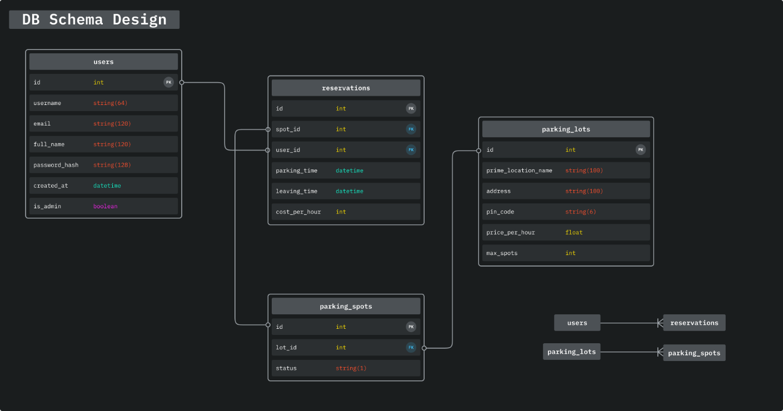

Architecture and Features
The project is organized following standard best practices for maintainability and clarity. All core application logic, including routes, models, authentication, and decorators, resides in the ‘app’ directory. The ‘routes.py’ file contains the routes for both admin and user functionalities, while ‘auth.py’ manages authentication and session logic. Database models are defined in ‘models.py’, and custom access control decorators are in decorators.py. HTML templates are stored in the ‘templates’ folder, with subfolders for admin, user, and authentication views, ensuring a clear separation of role-specific interfaces. The base layout and shared components are in ‘base.html’. The SQLite database file is in the ‘instance’ directory, and the project root contains setup files like ‘requirements.txt’, ‘run.py’, and documentation.

Features Implemented:
1. Core Features: Authentication System: User registration with username validation, secure password hashing, and session management using Flask-Login. Role separation between Admin (default superuser, no registration required) and User (register/login to reserve parking).
Admin Management: Full CRUD operations for parking lots and parking spots, user management and oversight, and prevention of lot deletion if spots are occupied. Admin dashboard provides quick access to management and reporting tools.
Parking System: Automated allocation of the first available parking spot to users, reservation and release of spots, cost calculation based on duration, and real-time spot status updates.
Reservation Management: Users can view active reservations, release spots, and access detailed parking history. Admins can view all reservations and user details.
2. Recommended Features: API Integration: RESTful endpoints for parking lots, spots, reservations, and user history, with standardized JSON response structures for easy integration and testing. Secure API routing with role-based access control.
Data Visualization: Usage analytics and revenue reports for admins, and parking history charts for users, implemented using Chart.js for interactive data visualization.
Reporting: Admin reports include total lots, spots, users, active/completed reservations, and total revenue (rounded to two decimal places).
3. Additional Enhancements: UI/UX Improvements: Responsive design using Bootstrap 5, clear navigation, dashboard shortcuts.
Form Validation: Frontend and backend validation for all forms, including registration, login, profile editing, and lot management.
Security Features: Input sanitization, protected routes via decorators, session security settings, and role-based access enforcement throughout the application.
Quality of Life: Default admin account auto-created on first run.

Video
https://drive.google.com/drive/folders/1-mZa3qJdER0mt70rox5wCF93x3OInvHm?usp=sharing

AI used
10-15% used for debugging and UI styling.

